Arsenal's World Cup winner looks dashing at Party in Las Vegas
Footballers do need rest after the long season with a grueling schedule. Arsenal’s Mesut Ozil looks to take full advantage of his free time after his World Cup campaign in Brazil as he won the Cup with the Die Mannschaft. The German midfielder was pictured partying with famous DJ Steve Aoki who announced the player as his special guest on Tuesday night.
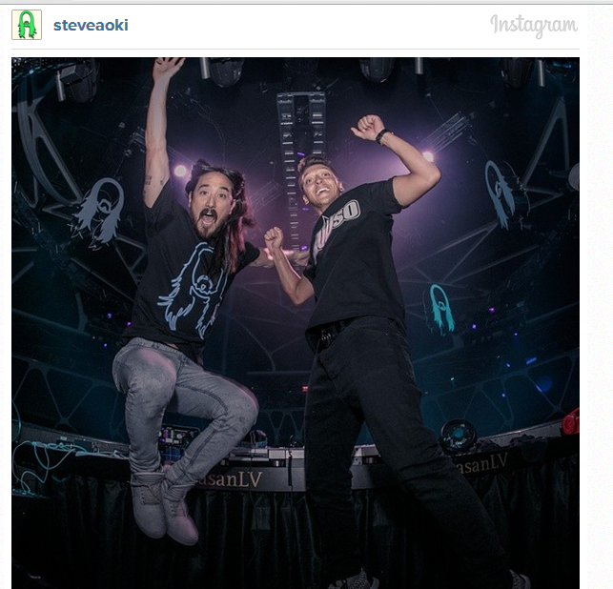
Picture Courtesy: Steve Aoki Instagram Account.
By the looks of it, the duo had an amazing time with awestruck fans and even managed to dump a large cake on the audience to cap off the mesmerizing party.

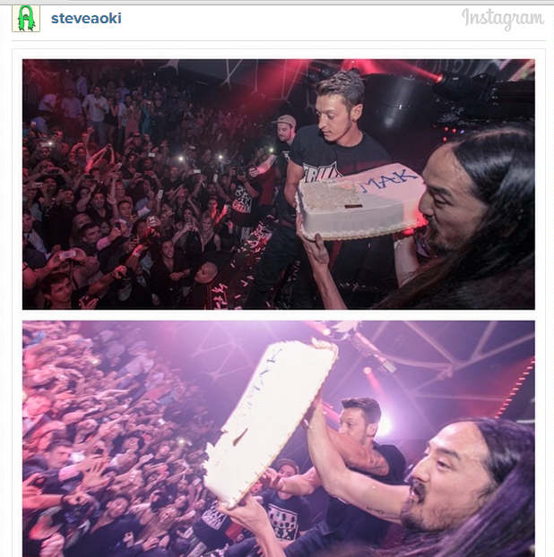
Ozil is expected to be back at the Gunners ahead of the brand new 2014-15 season as Arsenal’s summer dealings in the transfer market surely indicate manager Arsene Wenger will push for a serious title challenge in the coming season.
Ozil is expected to be the fulcrum of the London side and should be back with his teammates before next weekend’s Community Shield match against Manchester City.
